## Approval of expert model development and verification

Based on the actual situation that XX business has not yet performed data, FICO will introduce an expert approval model. By related industries the same type of business historical data, combined with the right business experts amendment of heavy build XX approval model.

**Expert model methodology (AHP analytic hierarchy process)**

The core of the expert model is to use the Analytic Hierarchy Process (AHP) to set the weight of each index of the scorecard.

The Analytic Hierarchy Process (AHP) is a comprehensive evaluation method of system analysis and decision-making created by the American operations researcher and professor at the University of Pittsburgh TLSaaty in the 1970s. It fully studies people's thinking processes. Put forward on the basis, it reasonably solves the qualitative problem and the quantitative processing process. The main feature of AHP is to transform people's judgments into a comparison of the importance of a number of factors by establishing a hierarchical structure, so that qualitative judgments that are difficult to quantify are transformed into a comparison of operational importance. In many cases, decision-makers can directly use AHP to make decisions, which greatly improves the effectiveness, reliability and feasibility of decision-making, but its essence is a way of thinking, which decomposes complex problems into multiple components, and These factors are formed into a hierarchical structure according to the dominance relationship, and the overall ranking of the relative importance of the decision-making scheme is determined by the method of pairwise comparison. The whole process reflects the basic characteristics of people's decision-making thinking, that is, decomposition, judgment, and synthesis, and overcomes the shortcomings of other methods that avoid the subjective judgment of decision-makers.

I. The basic methods and steps of Analytic Hierarchy Process: Using the analytic hierarchy process to make decisions can be roughly divided into four steps:

(1) Analyze the relationship between various factors in the system and establish the hierarchical structure of the system;

(2) Make pairwise comparisons of the importance of each element of the same level with respect to a criterion in the previous level, and construct a pairwise comparison judgment matrix .

(3) The relative weight of the compared element to the criterion is calculated by the judgment matrix, and the consistency test is performed .

(4) Calculate the composite weight of each layer element to the system target, and sort it .

The following describes the implementation method of these four steps in detail.

1. The establishment of hierarchical structure

The decision-making of complex problems involves more complicated factors and is usually difficult. The first step in applying AHP is to organize and hierarchize the factors involved in the problem to construct a hierarchical structural model. Under this model , the components of complex problems are divided into several components , called elements. These elements form several levels according to their attributes and relationships. The elements of the upper level dominate the relevant elements of the next level. These levels can be divided into three categories.

The highest level: also known as the target level. There is only one element at this level. Generally, it is the predetermined goal or ideal result of analyzing the problem.

Middle layer: also known as the criterion layer. This level includes the intermediate links involved in achieving the goal . It can be composed of several levels , including criteria and sub-criteria that need to be considered.

The lowest level: also known as the program level. This level includes various measures , decision-making schemes, etc. that can be selected to achieve the goal . The dominance relationship between the above levels is not necessarily complete, that is, there can be such an element, which does not dominate all the elements of the next level, but only dominates some of the elements. This top-down dominance relationship is formed The hierarchical structure is called the hierarchical structure. A typical hierarchical structure is shown in the figure.

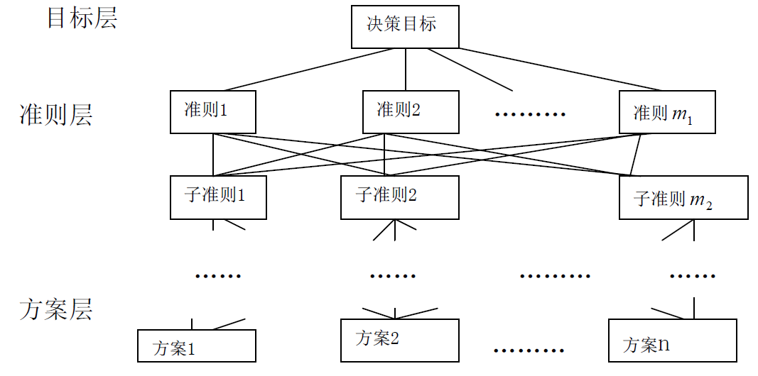

The number of levels in the hierarchical structure is related to the complexity of the problem and the level of detail to be analyzed. The general level is not limited, and each element in each level should not control more than 9 elements. Because too many dominating elements will make pairwise comparison and judgment difficult , if there are more than 9, you can consider combining some factors or increasing the number of layers. In either case, it must be carried out with an in-depth study of the problem in order to make it reasonable.

A hierarchical structure should have the following characteristics: (1) sequentially from top to bottom dominance relationship exists, a segment table and a straight line shown. Except for the target layer , each element is dominated by at least one element of the previous layer . Except for the last level, each element dominates at least one element at the next level, and the connection between the upper and lower elements is stronger than that of the same level to avoid the dominance of non-adjacent elements in the same level; (2) In the entire structure, the number of levels is not Restricted; (3) There is only one element at the highest level, and generally no more than 9 elements dominate by each element. If there are too many elements, it can be further grouped; (4) Some sub-level structures can introduce virtual elements to make It becomes the hierarchical structure.

2. Construct a pairwise comparison judgment matrix

One of the characteristics of Analytic Hierarchy Process is the combination of qualitative analysis and quantitative calculation, and quantification of qualitative problems. The second step is to construct a judgment matrix for pairwise comparison based on the existing hierarchical structure. In this step , the decision-maker has to answer the questions repeatedly , for criterion C, which element ui and uj dominated by the two C is more important, how important is it, and assign the importance degree on a scale of 1-9. The following table shows the meaning of scales from 1 to 9. In this way, for criterion C, several compared elements form a judgment matrix through pairwise comparison , among which  is the ratio of the importance of elements ui and uj relative to C.

The judgment matrix has properties:  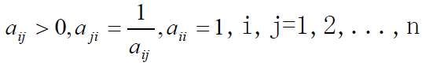

The matrix A with this property is called a reciprocal matrix. Knowing from the nature of the judgment matrix , an n-th order judgment matrix only needs to give the upper triangle or the lower triangle 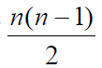 , that is, only need to make a  pairwise comparison judgment.

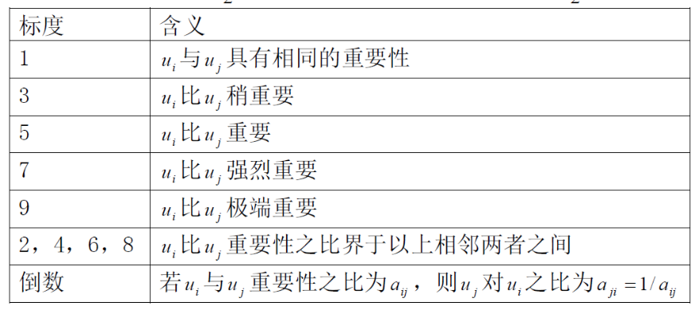

If the judgment matrix A having both properties: , called A is consistent matrix.  Not all judgment matrices are consistent. In fact, most judgment matrices (above third order) in AHP do not satisfy consistency. Consistency and its inspection are important contents of AHP.

3. Calculation of relative weight of elements and consistency check under a single criterion

In this step, on the basis of the second step, the order weight vector of the compared elements is obtained from each judgment matrix given, and the consistency check is used to determine whether each judgment matrix is acceptable.

(1) Weight calculation method

(1) Sum method: Take the normalized arithmetic mean of the n column vectors of the judgment matrix (for the n-th order judgment matrix) as the weight vector, that is, there is

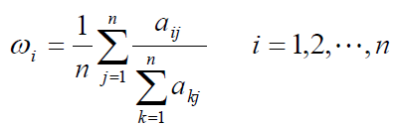

(2) The root method (geometric mean) takes geometric average of each column vector of A and then normalizes it, and the obtained column vector is approximated as a weighted vector.

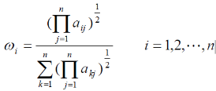

(3) Eigen-root method (EM): Find the largest eigenvalue of the judgment matrix and its corresponding right eigenvector, which are called the main eigenvector and the right eigenvector respectively, and then use the normalized right eigenvector as the sorting weight vector. The characteristic root method is the earliest and most respected method in AHP. In addition to the above methods, there are logarithmic least squares method, minimum deviation method, gradient eigenvector method and so on.

(2) The principle and algorithm of the characteristic root method

Supposeis the sorting weight vector of the n-th order judgment matrix A. When A is the consistency matrix, there are obviously:

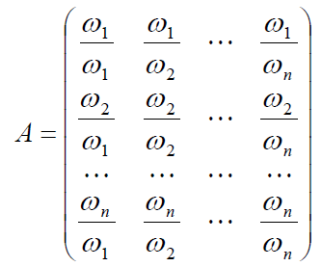

Can be verified

And n is the largest characteristic root of matrix A, the remaining characteristic roots of A are 0, and the rank of A is 1. For general positive and reciprocal matrices, according to the Perron theorem of positive matrices (see Theorem 2 below), it can be seen that the largest characteristic root; it is positive, and its corresponding right eigenvector is a positive vector, and the largest eigenvalueis the single eigenvalue of A, so its corresponding eigenvector is unique except for a constant factor. The characteristic root method is realized by using the power method of calculating the largest characteristic root and characteristic vector of a positive matrix in numerical analysis. Commonly used mathematical software such as Mathematica also has this function.

(3) Consistency test

As mentioned earlier, in the construction of the judgment matrix, the judgment matrix is not required to be consistent. This is determined by the complexity of objective things and the diversity of human understanding. The scale of 1-9 also determines the judgment of the third order or higher. The matrix is difficult to meet consistency. But it is necessary to require judgments to have general consistency. It is generally against common sense that A is extremely important than B, B is extremely important than C, and C is extremely important than A. A confusing judgment matrix that cannot withstand scrutiny may lead to mistakes in decision-making, and the reliability of the above-mentioned various methods of calculating ranking weights is questionable when the judgment matrix deviates too much from the consistency. Therefore, the consistency of the judgment matrix needs to be tested, and the test steps are:

(i) Calculate the consistency index C.I. (Consistency Index)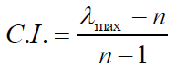

(ii) Find the corresponding average random consistency index R.I. ( Randomytidex ). The following table shows the average random consistency index of the 1-12 order reciprocal matrix.

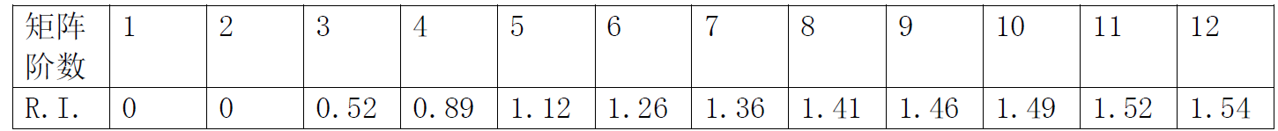

(iii) Calculate the consistency ratio C.R. (Consistency Ratio)

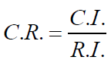

When C.R.<0.10, the consistency of the judgment matrix is considered acceptable, otherwise the judgment matrix should be appropriately modified. In order to discuss consistency, it is necessary to calculate the largest characteristic root . In addition to the characteristic root method, the fraction

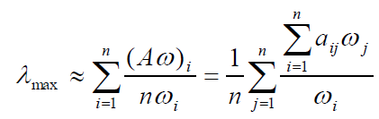

can be used to obtain  in the formula, which is the i-th component of the vector  .

(4) Calculate the total sorting weight of each layer element to the target layer

What is obtained above is the weight vector of a set of elements to an element in the previous level. We finally need to get the sorting weight of each element, especially the lowest level case for the target, the so-called total sorting weight, so as to choose the scheme. The total ranking weight is important to synthesize the weights under a single criterion from top to bottom.

of the  element on the (k-1) level relative to the total target has been calculated, and the kn elements of the kth level are the criterion for the single sorting vector A picture containing text, watch, gauge
of the j-th element on the (k-1) level. , Where the weight of elements not dominated by the j-th element is taken as 0. The matrix  is an -order matrix, which represents the ordering of the elements on the k-th layer to the elements on the (k-1)th layer, then the total ordering vector  of the elements on the k-th layer to the target is 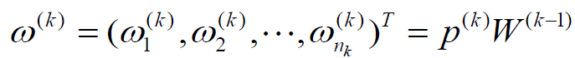 Here  is the total sorting vector of the elements on the second level, and it is also the sorting vector under the single criterion.

### 6.3.2.1 Model finalization and document writing

Model finalization and document writing include the preparation of the final model and the record of the entire modeling process and results. This stage is usually carried out with a meeting or formal presentation.

FICO will provide XX with detailed methods, analysis reports and usage reports for each step of the model development process. The final scoring model document usually consists of the following components:

• Overview of project objectives

• Model design

• Segmentation analysis

• Expert model development methodology, process and results

• Classification/division of risk levels

• Scoring rules